A picture containing clipart

Description generated with very high confidence

NodeJS Module 6

Hands On - 4

[**support@intellipaat.com**](mailto:support@intellipaat.com)

**+91-7022374614**

**US: 1-800-216-8930(Toll Free)**

**NodeJS Module 6: Hands-on: 4**

**Handling Multiple Routes in Express.**

**Step 1:** Open command prompt inside an npm project folder with express installed.

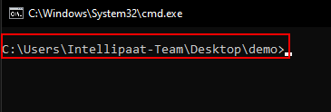

**Step 2:** Run command npm install ejs.

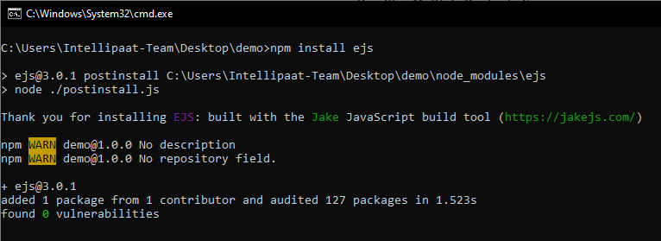

**Step 3:** Create a file named app.js and write the following code in it.

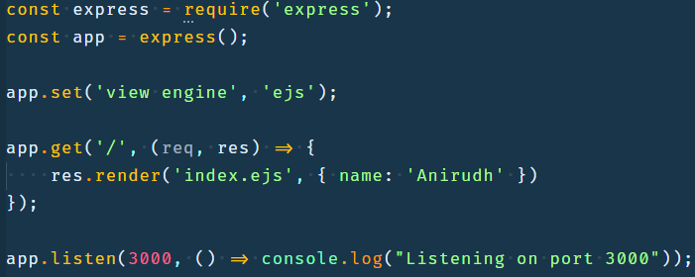

**Step 3.1:** Import the express module using the ‘require’ keyword.

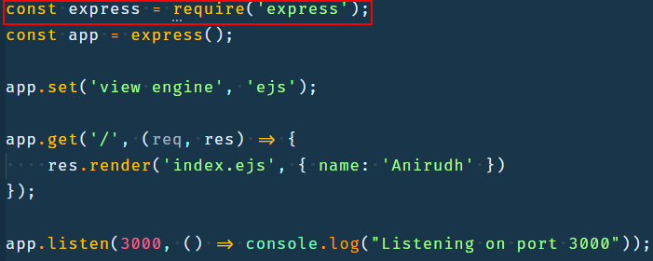

**Step 3.2:** Create an express app by calling the express function imported in previous step.

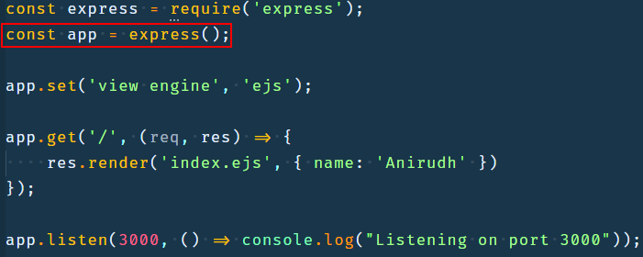

**Step 3.3:** Call the app.set method and set the view engine to ejs.

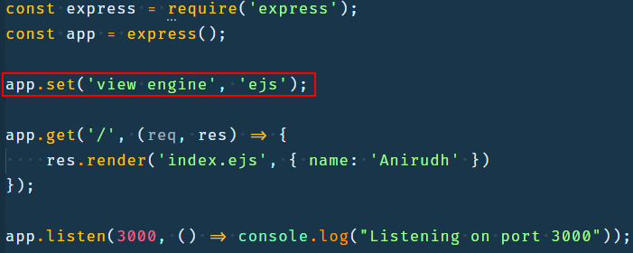

**Step 3.4:** Register a route for a get request to the root url using the app.get method.

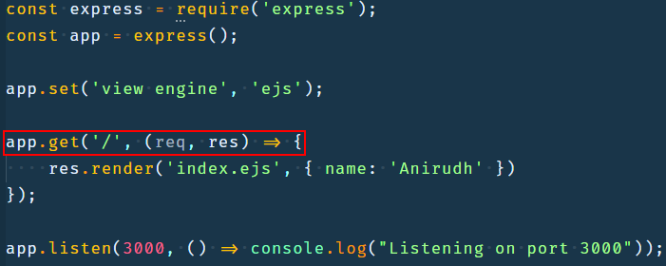

**Step 3.5:** Inside the get method pass ‘/’ to denote root url and a callback that accepts the request and response objects created by express and render a template named index.ejs and also pass an object with key as name and value that you like to display in the template

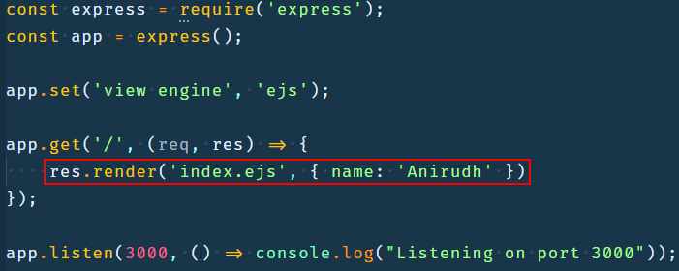

**Step 3.6:** Create a server and listen on port 3000 and print ‘Listening on port 3000’ after server is created using the listen method.

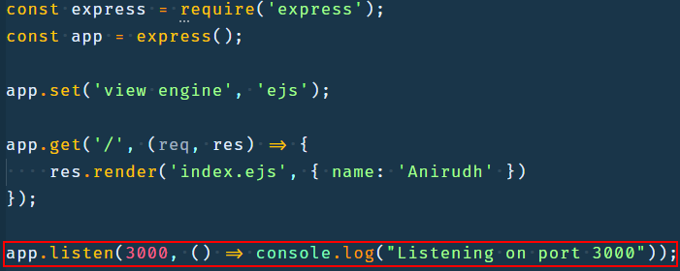

**Step 4:** Create a file named index.ejs inside a folder named views inside your project folder and write the following code in it.

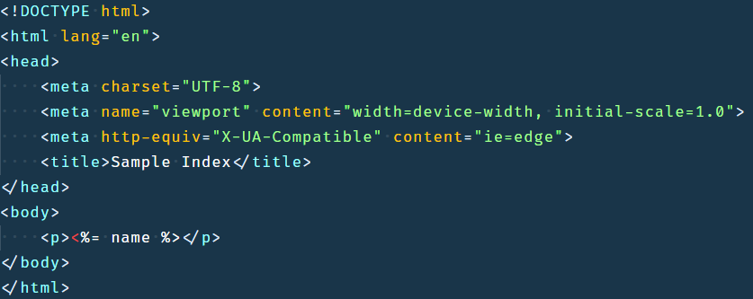

**Step 4.1:** The code is mostly plain HTML with name being dynamically replaced by view engine with the value of name key that we passed in render method in previous step

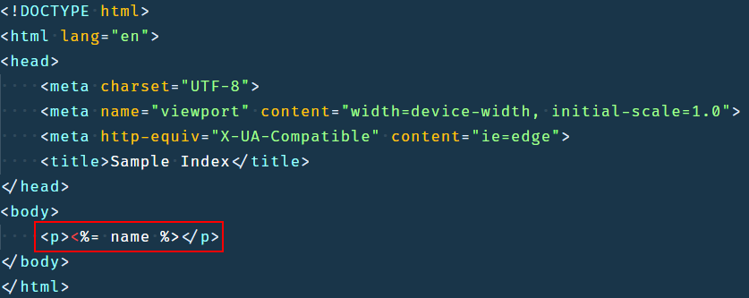

**Step 5:** Open cmd in the same project directory.



**Step 6:** Run the file using the command ‘node app.js’.

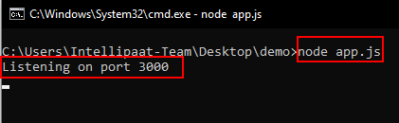

**Step 7:** Open the browser on localhost:3000 and look at the output.

